EXPERIMENT-4

RELATIONAL MODEL FOR SAILOR BOAT DATABASE

**Aim:** Draw a relational model for sailors’ database.

**Components:**

* Tables:
  + Sailor
  + Boat
  + Reserves
* Degree
  + Sailor – 4
  + Boat – 3
  + Reserves – 1

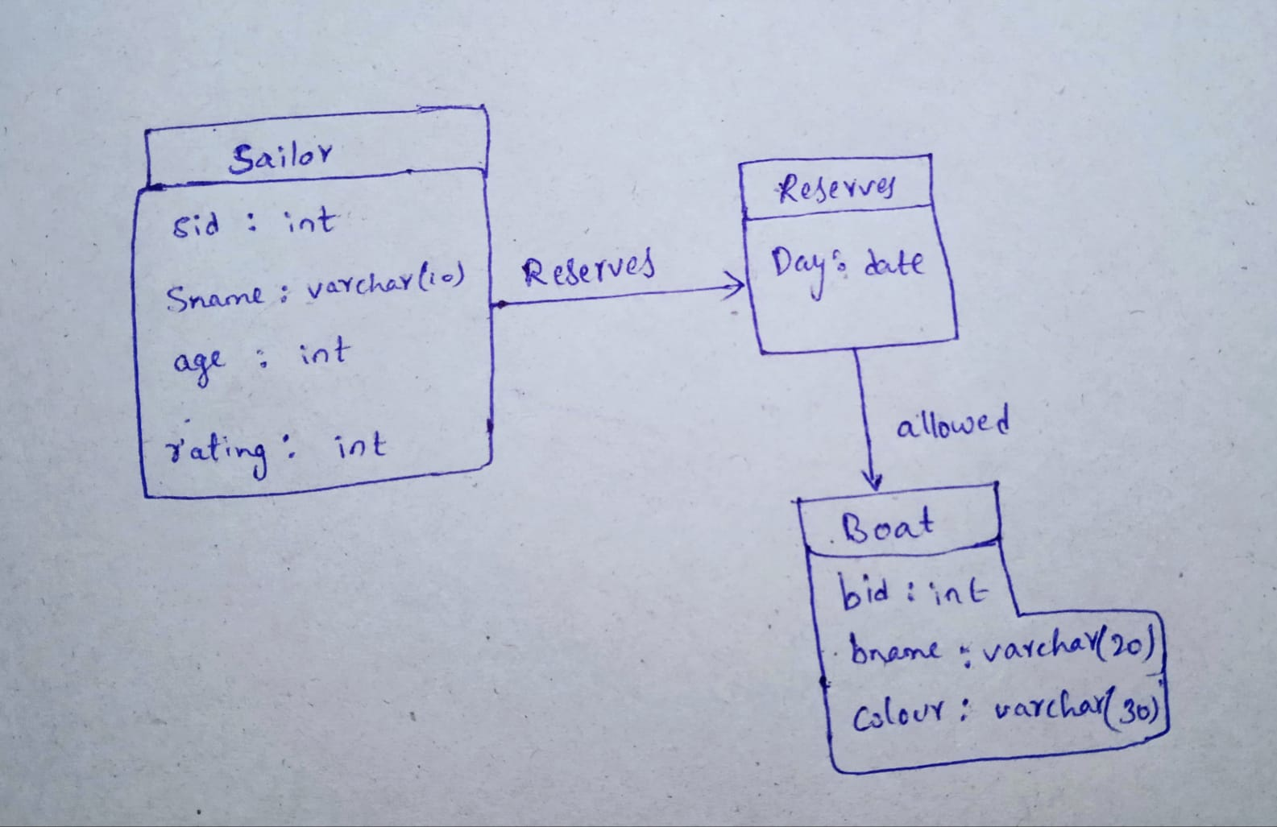

|  |
| --- |
| Sailor |
| sid int |
| sname varchar(20) |
| age int |
| rating int |

|  |
| --- |
| Reserves |
| day date |
|  |
|  |
|  |

allocated

|  |
| --- |
| Boats |
| bid int |
| bname varchar(20) |
| color varchar(9) |
|  |